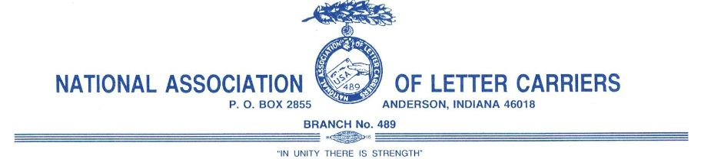

NALC Branch #489 Meeting Notice

Branch meetings are held on the third Thursday of each month at the UAW Union hall at 2840 S. Madison Avenue, Anderson, Indiana. Local meetings are currently scheduled for the following days / months:

January 19, 2017
February 16, 2017
March 16, 2017
April 20, 2017
May 18, 2017
June 15, 2017
July 20, 2017
August 17, 2017
September 21, 2017
October 19, 2017
November 16, 2017
December 21, 2017

January 18, 2018
February 15, 2018
March 15, 2018
April 19, 2018
May 17, 2018
June 21, 2018
July 19, 2018
August 16, 2018
September 20, 2018
October 18, 2018
November 15, 2018
December 20, 2018

Dates are subject to change and if so a 30 notification will be given to all branch members.

Greg Felts, President

